Log Issue in Qradar

After qradar community installation is done, the port 514 is not open to listen

link: https://www.ibm.com/support/pages/updated-qradar-deploy-changes-31-december-2020-can-impact-product-functionality

1) check the log for license warning

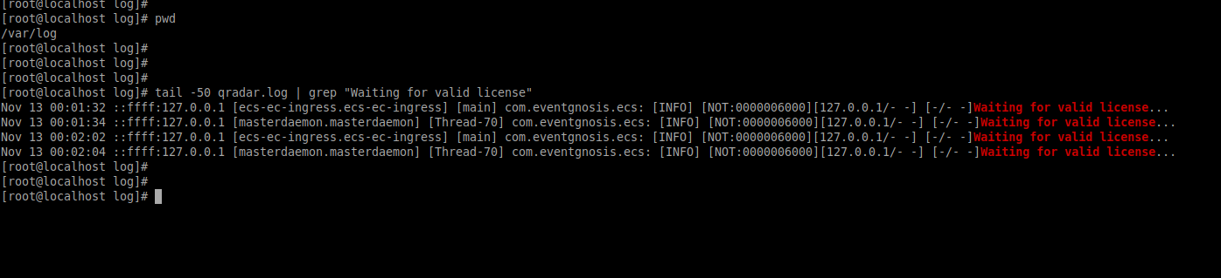

2) run the command as mentioned in the link

if [ -f /opt/qradar/ecs/license.txt ] ; then echo -n "QRadar:Q1 Labs Inc.:0007634bda1e2:WnT9X7BDFOgB1WaXwokODc:12/31/20" > /opt/qradar/ecs/license.txt ; fi ; if [ -f /opt/ibm/si/services/ecs-ec-ingress/current/eventgnosis/license.txt ] ; then echo -n "QRadar:Q1 Labs Inc.:0007634bda1e2:WnT9X7BDFOgB1WaXwokODc:12/31/20" > /opt/ibm/si/services/ecs-ec-ingress/current/eventgnosis/license.txt ; fi ; if [ -f /opt/ibm/si/services/ecs-ep/current/eventgnosis/license.txt ] ; then echo -n "QRadar:Q1 Labs Inc.:0007634bda1e2:WnT9X7BDFOgB1WaXwokODc:12/31/20" > /opt/ibm/si/services/ecs-ep/current/eventgnosis/license.txt ; fi ; if [ -f /opt/ibm/si/services/ecs-ec/current/eventgnosis/license.txt ] ; then echo -n "QRadar:Q1 Labs Inc.:0007634bda1e2:WnT9X7BDFOgB1WaXwokODc:12/31/20" > /opt/ibm/si/services/ecs-ec/current/eventgnosis/license.txt ; fi ; if [ -f /usr/eventgnosis/ecs/license.txt ] ; then echo -n "QRadar:Q1 Labs Inc.:0007634bda1e2:WnT9X7BDFOgB1WaXwokODc:12/31/20" > /usr/eventgnosis/ecs/license.txt ; fi ; if [ -f /opt/qradar/conf/templates/ecs_license.txt ] ; then echo -n "QRadar:Q1 Labs Inc.:0007634bda1e2:WnT9X7BDFOgB1WaXwokODc:12/31/20" > /opt/qradar/conf/templates/ecs_license.txt ; fi

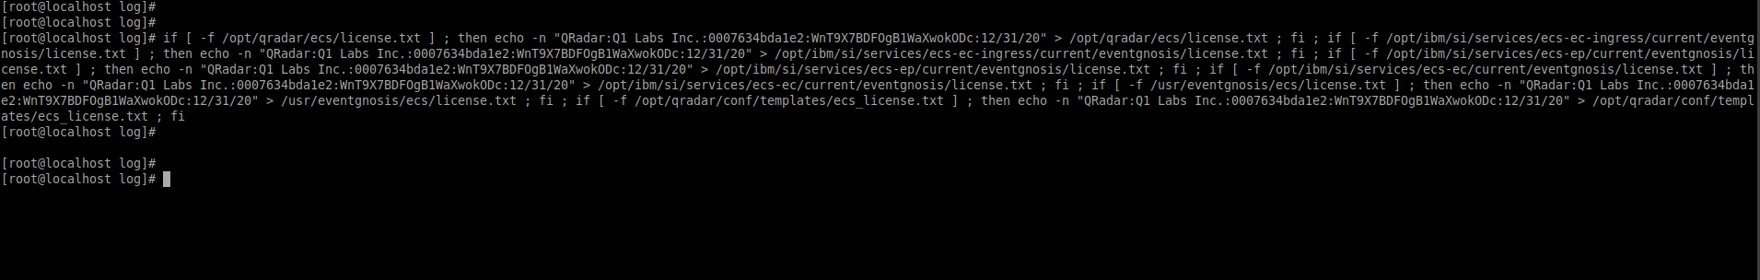the port 514 is not open and listening

